3.10: a) The time t is given by 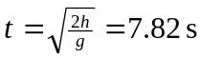.
b) The bomb’s constant horizontal velocity will be that of the plane, so the bomb travels a horizontal distance 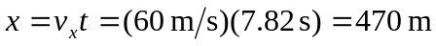.
c) The bomb’s horizontal component of velocity is 60 m/s, and its vertical component is 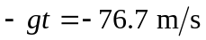.
d)
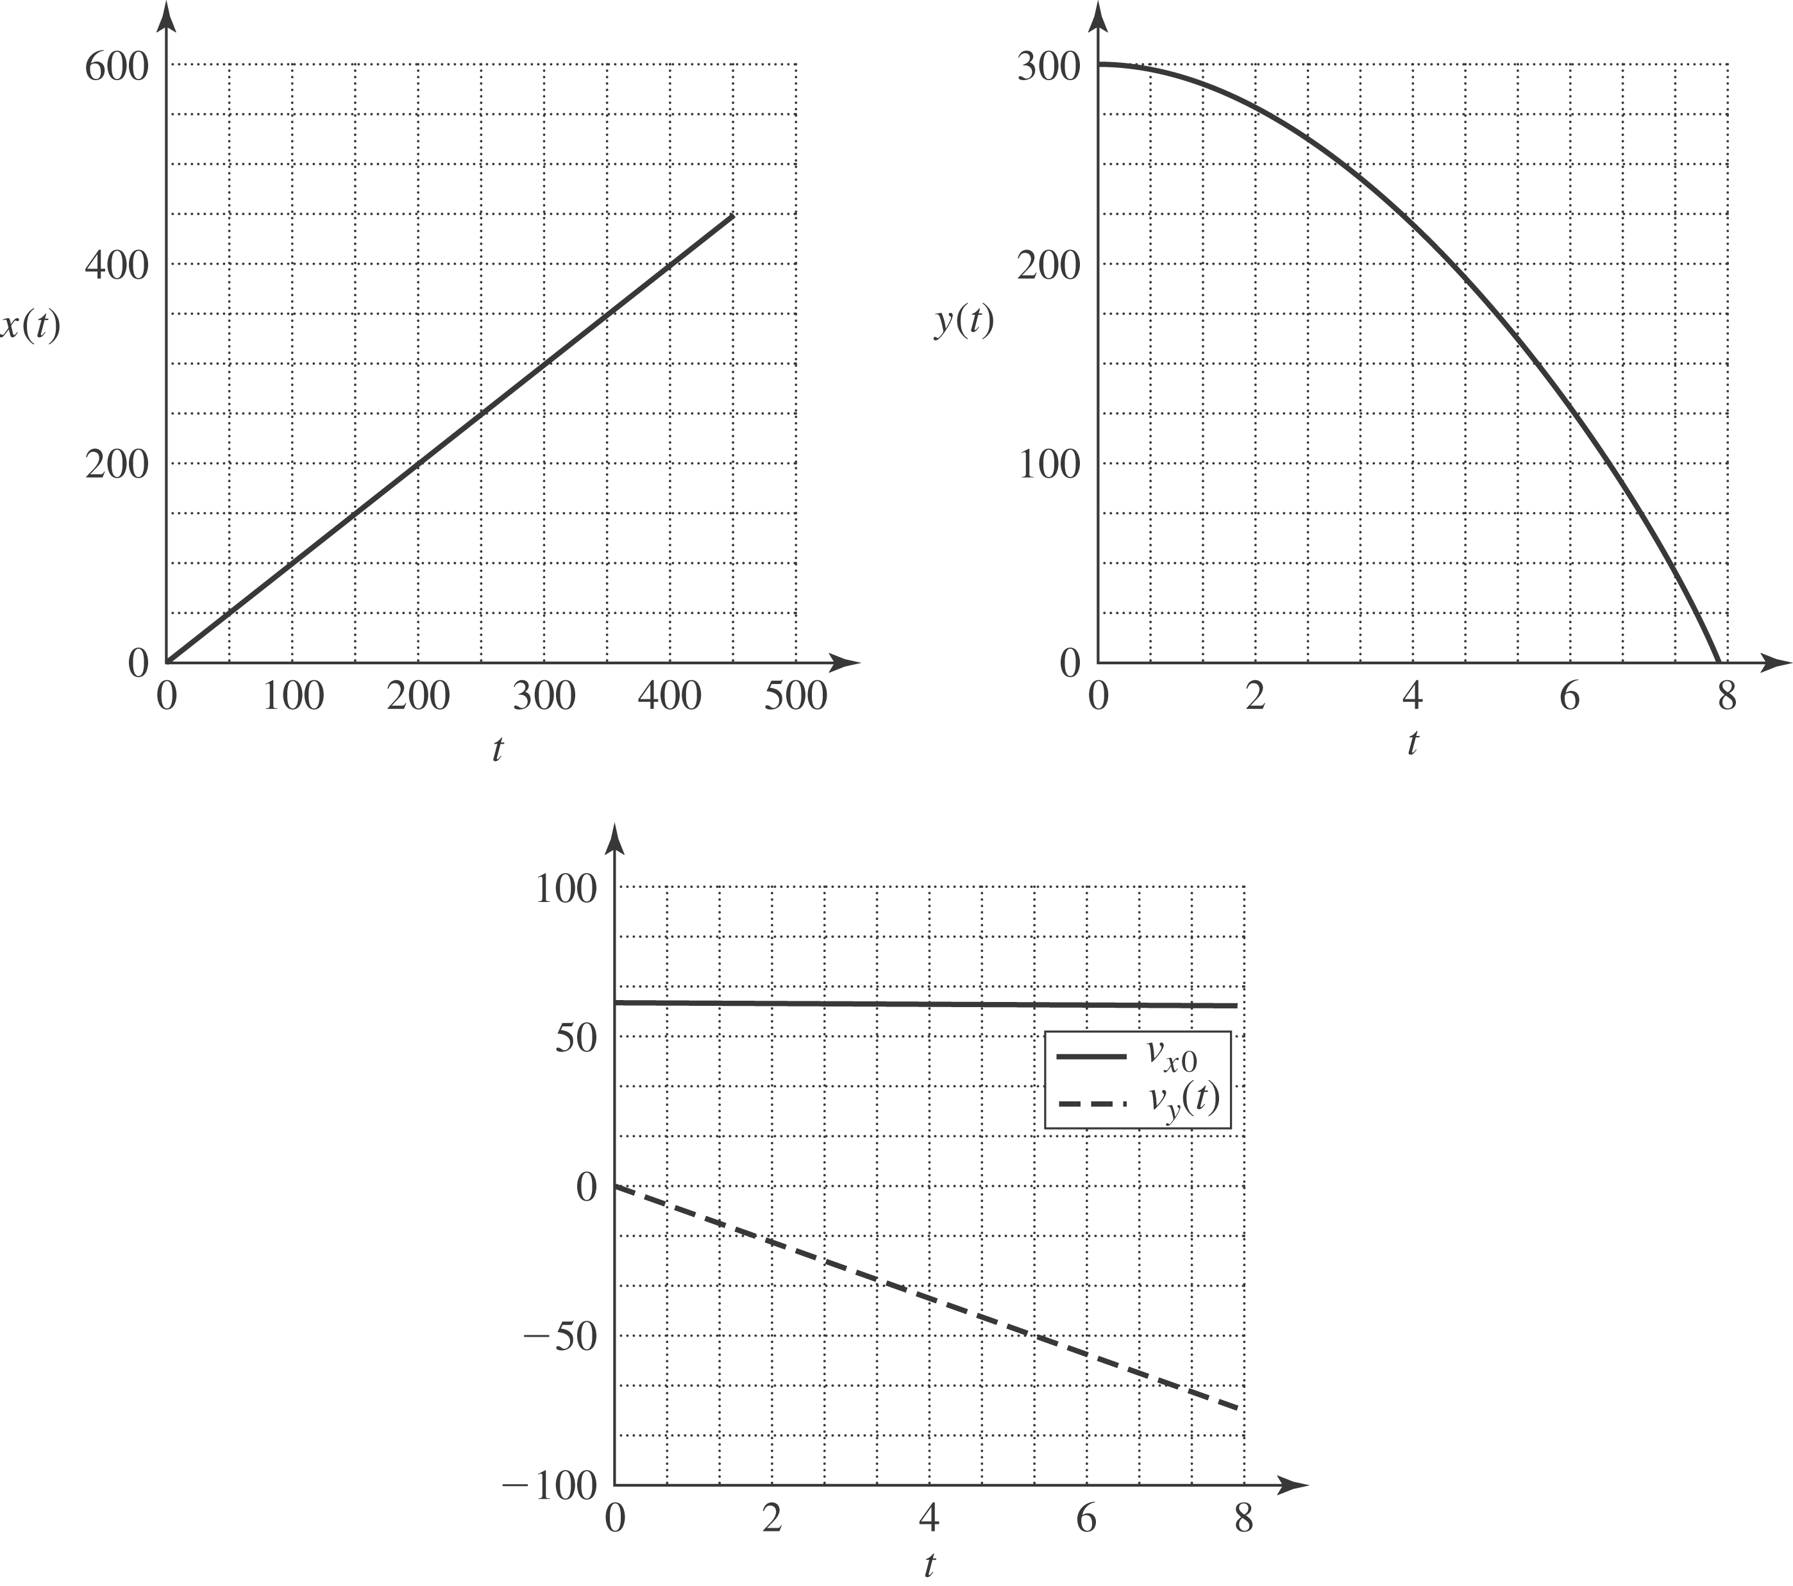

e) Because the airplane and the bomb always have the same x-component of velocity and position, the plane will be 300 m above the bomb at impact.

